Cinnamon Whiskey BBQ Chicken Wraps
Prep Time 40 minutes Cook Time 15 minutes
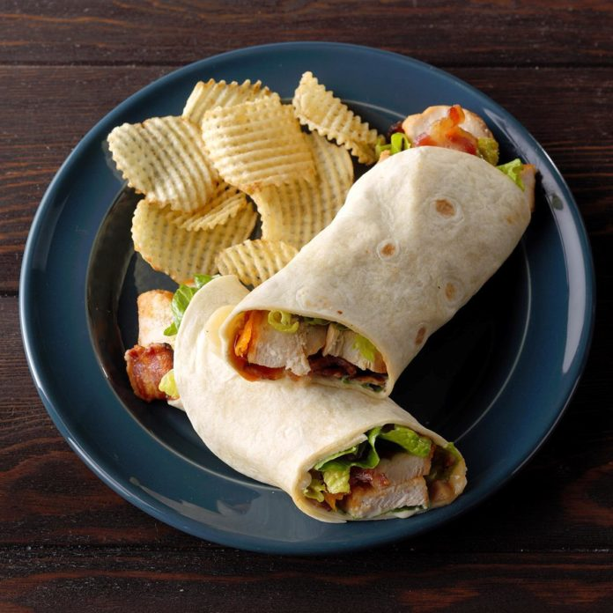
2 Servings
Ingredients
1/3 cup packed brown sugar
1/3 cup ketchup
2 tablespoons cider vinegar
2 tablespoons cinnamon whiskey
3/4 teaspoon Worcestershire sauce
3/4 teaspoon molasses
1 small garlic clove, minced
1/4 teaspoon pepper
Wrap
2 boneless skinless chicken breasts
Shredded cheddar cheese
Ranch salad dressing
4 flour tortillas (10 inches)
4 bacon strips, cooked and crumbled
Shredded lettuce, optional
Directions
- In a small saucepan, combine the first 8 ingredients. Bring to a boil and reduce heat. Simmer covered until thickened, 5-8 minutes.
- Cook chicken in a frying pan with oil 5-6 min per side basting with sauce occasionally. Let stand 5 minutes before shredding or slicing into strips or cubes.
- Spread dressing over tortillas. Top with chicken; drizzle with sauce. Top with bacon, cheese and if desired, lettuce. Fold bottom of tortilla over filling; fold both sides to close.

